
Year 8 Science 2015

Energy Topic Test

  - Name ____________________________
  - Teacher ____________________________
  - Score _____ / 40 _____ %

 | Cells are the basic building blocks of:  - plants, but not animals.  - animals, but not plants.  - all living things | C | 1
 | Which one of the following is not a type of microscope?  - A proton microscope  - A scanning electron microscope  - A light microscope | A | 1
 | Which of these was viewed at a larger magnification?  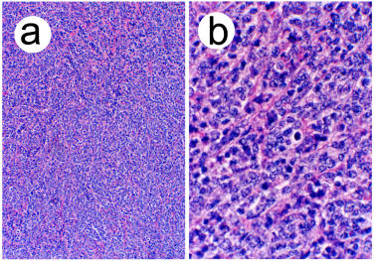 | B | 1
 | A drop of pond water is to be viewed using a microscope.  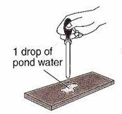  This picture shows that it should first be put on:  - the stage.  - a slide.  - a coverslip.  - a lens. | B | 1
 | The control centre of a cell is:  - the nucleus.  - the epicentre.  - the cytoplasm.  - the DNA. | A | 1
 | The pigment that makes plants look green is found in their cells. It helps make food out of sunlight. It is called:  - algae.  - chlorophyll.  - lime cordial. | B | 1
 | The cell membrane of living cells:  - supplies energy to all of the other parts of the cell.  - controls the flow of substances in and out of the cell.  - is the part of the cell where photosynthesis takes place. | B | 1
 | A very large vacuole can be found inside the cells of:  - plants.  - animals.  - fungi.  - bacteria. | A | 1
 | Which of these animal cells have tails that allow them to swim?  - Blood cells  - Trachea cells  - Ova  - Sperm | D | 1
 | Which of the following is one of the biggest differences between plant and animal cells?  - Plant cells have a cell wall, animals do not  - The nucleus is in a different position  - Animals have cytoplasm, plants do not | A | 1
 | When lots of similar cells combine, you get:  - team cells.  - organs.  - organelles.  - tissues. | D | 1
 | Identify parts (a) to (e) on the microscope diagram below.  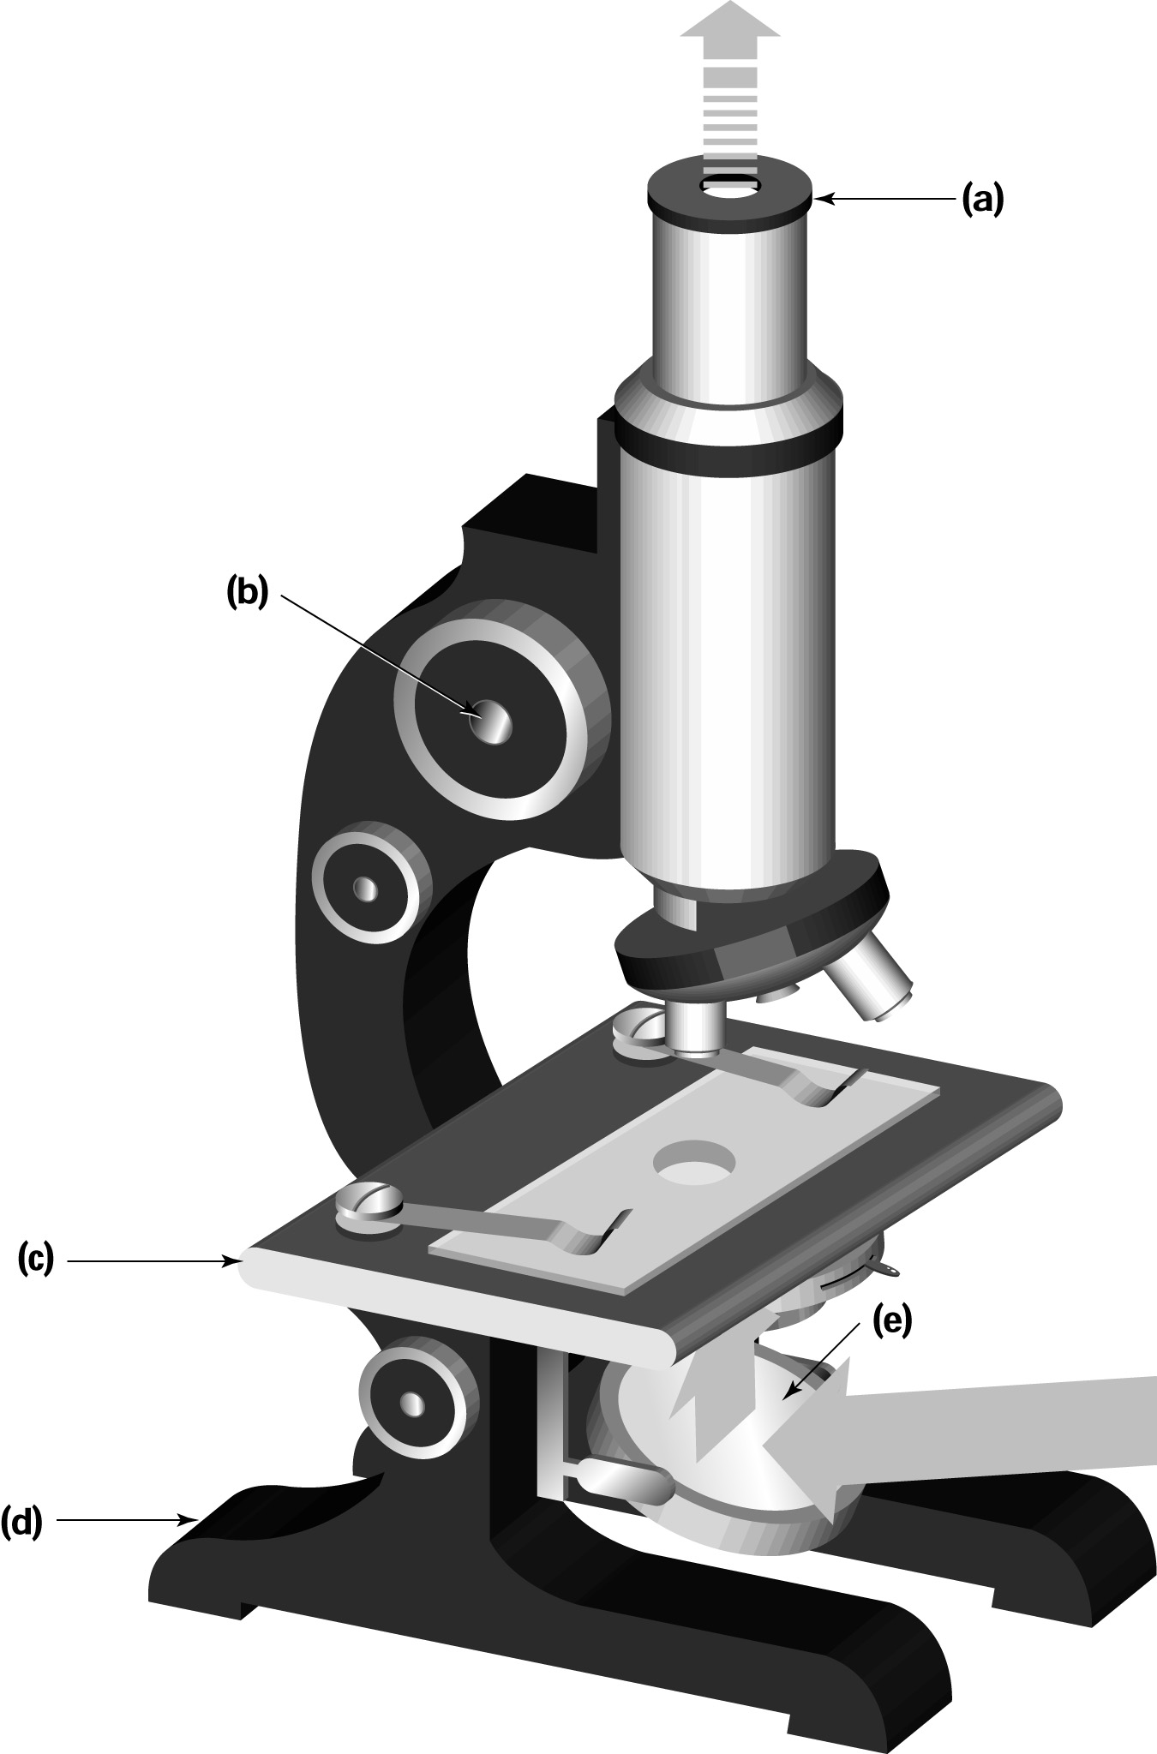 | - Eyepiece lens  - Focus knob  - Stage  - Base  - Mirror/Light source | 5
 | Give two tips for the effective use of a microscope. | Answers will vary but may include:  - Use the microscope on a flat surface.  - Watch from the side when lowering the objective (lower) lens. | 2
 | Pick the correct words to make a true statement:  ‘The human body is made up of a large/small number of different/identical cells.’ | The human body is made up of lots of different cells. | 2
 | Draw a simple sketch of an animal cell. Label the cell membrane and the nucleus. | 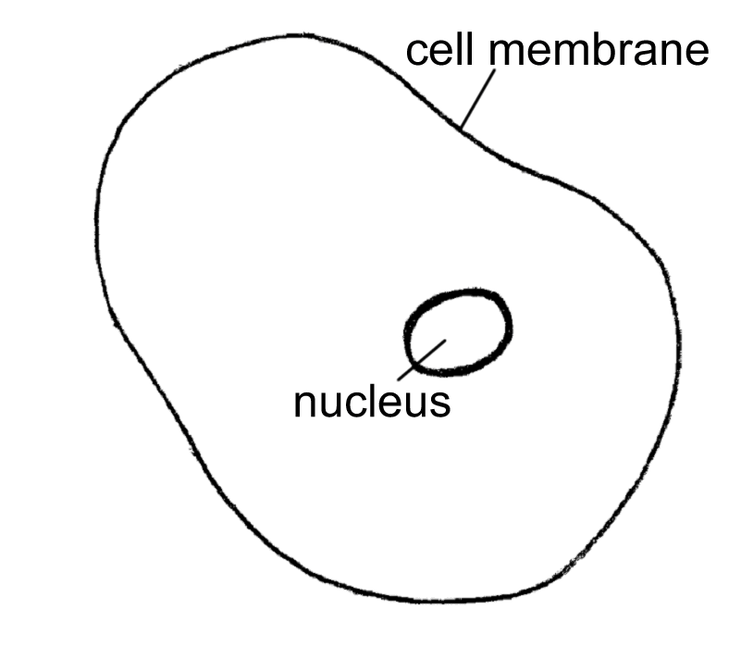 | 3
 | Name three of the kingdoms into which organisms may be grouped. | Kingdoms include:  - Animalia  - Fungi  - Plantae  - Prokaryotae (Monera)  - Protoctista (Protista). | 3
 | What small structures in a cell create energy for the cell? Hint: they are called the powerhouse of the cell.  M _ _ _ C H _ _ D _ _ A | Mitochondria | 1
 | Copy and complete the following sentence:  The large storage cavity in the centre of a plant cell is called a V _____. | The large cavity in the centre of a plant cell is called a vacuole. | 1
Organelle Animal cell Plant cell  Nucleus Present Present  Cell wall Absent Present  Cell membrane Present Present  Cytoplasm Present Present  Large vacuole Absent Present  Chloroplast Absent Present  Organelle Animal cell Plant cell  Nucleus ✓ ✓  Cell wall ✗  Cell membrane ✓  Cytoplasm  Large vacuole ✗  Chloroplast ✓ | Use ticks and crosses to identify which organelles are found in the various cell types. Some have been done for you. |  | 6
 | List three different types of animal cell. | Examples include: blood, cheek and muscle cells. | 3
 | These are pictures of plant and animal cells. What are the differences between plant and animal cells?  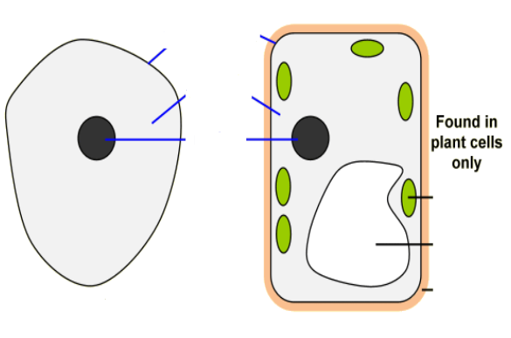 | Plant cells have a cell wall and a large central vacuole. A plant cell may also contain chloroplasts. | 3

